|  |
| --- |
|  |
| EVOLUTIONARY TRADE-OFFS |
|  |
|  |
| **AMRITA MUKHERJEE** |
| **184303011**  **CL717** |

|  |
| --- |
|  |

INDEX

* What is Trade off? 3
* What are the conditions that lead to tradeoffs between traits? 4
* Questions that can be raised throughout the sem-long project 7
* References 8

Evolutionary Tradeoffs

* 1. **What is Trade off?**

Evolution has never failed to surprise us. The most surprising aspect of life on Earth is its extensive diversity. The diversity exists with varying evolutionary success, fitness and adaptability between species. But the point is, why, the one with the most fit, most strong genotype never takes over the entire earth excluding everything else, although it was supposed to do so. I mean, it is the best among all, right?

And this never happened in reality. The reason, - the nature has set a rule. To gain something, one has to pay a price. Be the cost bigger or smaller, but definitely a cost to be considered. In Goethe’s Law of compensation it is described as “In order to spend on one side, nature is forced to economise on the other side” [1]. This type of negative correlation between biological traits is simply called a ‘Trade-off’. The importance of TRADE-OFFS lies in the fact that they constrain the range of phenotypes open to organisms [2]. They basically prevent the evolution of a so called Darwinian demon (a species that breeds fast, lives long and is both a good competitor and disperser). Trade-offs are also thought to be important in ecology, driving the speciation, adaptive radiation and co-existence in communities [3].

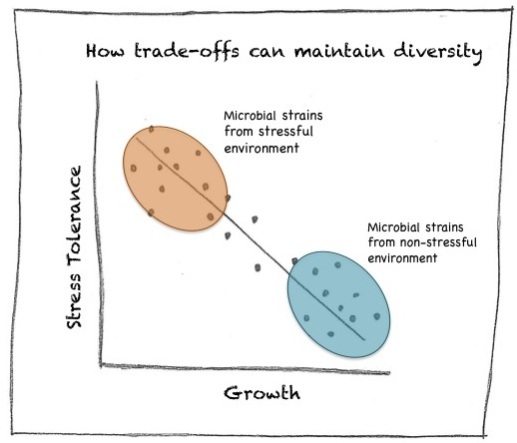

Fig: <http://bigsciencelittlesummaries.com/trade-offs-are-important-for-promoting-diversity-even-for-microbes/>

In biological system, generation of trade off needs two important factors to be under the same roof- A varying environment and two oppositely correlating traits. The relationship between traits and their corresponding tradeoffs are difficult to study in higher organisms whereas the simplicity of microorganisms, especially the bacteria, makes them a better platform to study the causes and underlying mechanisms of evolutionary tradeoffs.

* 1. **What are the conditions that lead to trade off between two traits?**

Scientists have discovered a lot of evidence that tradeoffs exist in microbial world but little knowledge about how they have evolved, and what are the factors that leads to this kind of phenomena. They have found that many eminent bacterial characteristics display negative correlations to other traits. They come in pairs or in multiple sets. Bacterial diversity has been derived from the core of the trade off events, though they are thought to be not the sole contributors [4].

To solve the question scientists took a molecular approach to understand the trade off [2]. They identified three processes resulting in tradeoffs:

* Resource allocation ( how cellular resource is channelized to support two different traits)
* Design constraint ( how architecture of proteins/enzymes lead to two different functions/ fate in bacteria)
* Information processing ( the cost of storing the genetic information vs. the benefits associated with it)
  + 1. **Resource allocation tradeoffs**:

The intracellular resources, i.e. nutrients, metabolites, different pathways or the output of transcription can be branched into different end points. In more complex organism, sub-cellular compartments aids to the process [5]. This alternative channelling of resources leads to trade of between two different traits. Here are some of the examples how division of cellular resources have resulted into two distinct fates, one leading improved survival under stress another more rapid vegetative growth.

|  |  |
| --- | --- |
| Trait 1 having benefit in one environment | Cost associated with trait 2 |
| Certain strains of *Escherichia coli* express RpoS(σS), that shifts the cellular resources from vegetative genes (RpoD, σD). This results in more survival under stress conditions. [6] | **RpoD, σD**, which is used to transcribe the housekeeping genes, lags behind and the growth rate reduces, resulting **less multiplication**. |
| Bacteria that express *lac* permease gene, helps in lactose uptake, favours survival in glucose deficient condition. [7] | The energy rich expression of *lac* genes becomes a burden to the cell and there is a reduction in their growth. |
| In *Pseudomonas aeruginosa*, more and more Oxygen is accessed at air water interfaces through pellicle formation. [8] | This reduces the uptake of iron leading a nutritional trade off between O2/Fe acquisitions. |

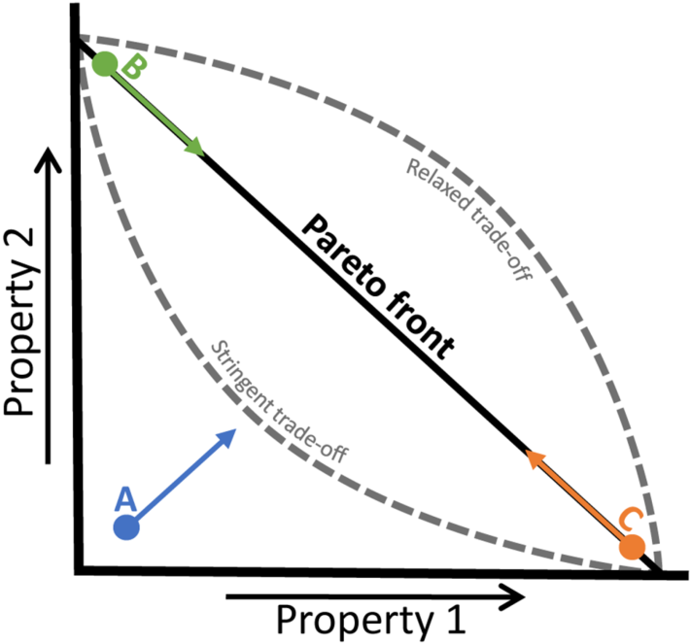

**Fig. Showing two traits exhibiting a trade-off**

* + 1. **Design constraints tradeoffs:**

When mutations changing in amino acid sequences results in generating proteins with some different functions that may be overlapping or completely new, two different phenotypes can arise. In case of enzymes there is a trade off between enzyme specificity (how accurately it recognises its substrate) and turnover number (reflects speed of the enzyme). I would like to share few examples showing how a design of biomolecules operates tradeoffs in bacteria.

|  |  |
| --- | --- |
| Trait 1 | Trait 2 |
| In pathogenic *E.coli,* mutations in Fimbriae (fimH) genes increase the epithelial adhesion. It aids in their virulence. [9] | The same mutant protein has a reduced binding property, hence are incapable of biofilm formation that in turn reduces their host survival. |
| Bacteria resistant to lambda phage lack the wild type glycoprotein that helps it to escape from phage recognition. [10] | The same glycoprotein used as a transporter channel for sugar uptake, i.e. a loss of ability to use diverse sugars. |

* + 1. **Informational processing tradeoffs**

The storage of genetic information has considered being a huge cost for cell because a large amount of energy is allocated in maintaining and replicating large microbial genome. The size of genome varies among microbial species. The reduction of genome can be selectively advantageous but again, it comes with the risk of losing the beneficial genes or genes that can be selected out under a different set of environments. This type of trade off is highly popular in bacterial populations and the consequences turns out to be pretty much interesting.

|  |  |
| --- | --- |
| Trait 1 | Trait 2 |
| Bacteria possessing mutator mutation (a high mutation probability) likely to gain more beneficial mutation over a short period of time[11] | A high mutation rate easily accumulates deleterious mutations reducing the fitness of the species |
| Loss of genetic material (bearing biosynthetic genes) reduces cellular burden, growth rate increases. [12] | It minimizes the niche of the species, fitness reduces when subjected to minimal media. |
| High recombination efficiency (expression of rec genes) in yeast reduces its multiplicity. [13] | The informational exchange property servers a lot of benefits that increases adaptations in the species. |

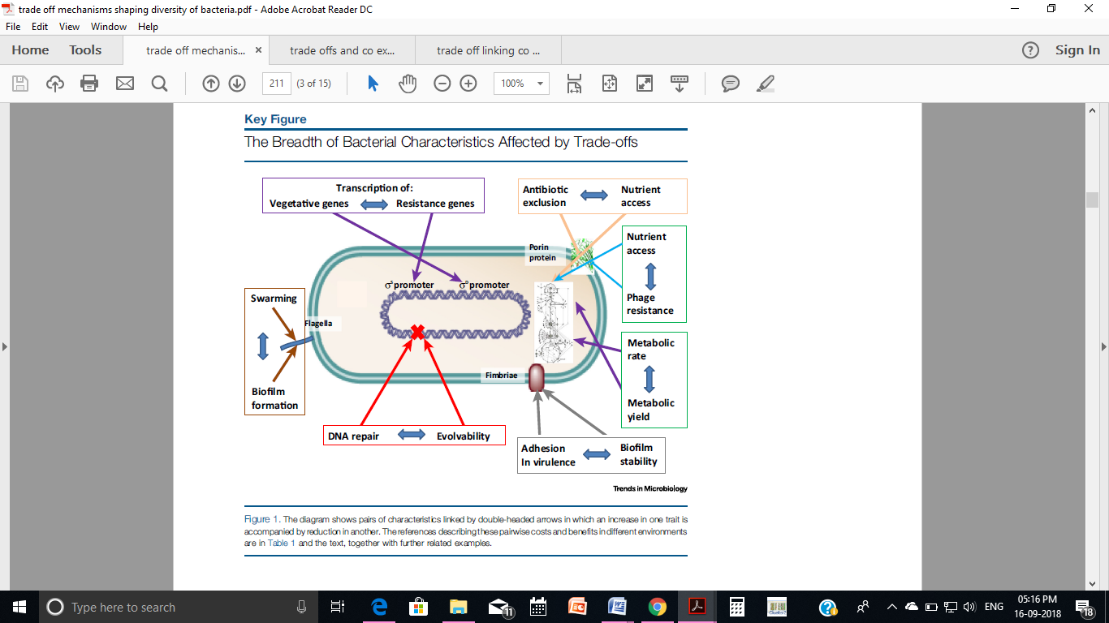

**Fig showing the breadth of bacterial characteristics affected by trade offs**

Well, in this semester long project, I would like to focus on few questions.

1. **Does a beneficial mutation always come with a cost associated with** **it** or tradeoffs are exclusive for fewer traits?
2. Does selection select out one of the two extremities or they co-exist with each other?
3. What happens to the intermediate organisms?
4. Microbial tradeoffs are diverse in nature, of which very few mechanisms are understood till date. Most of the literature shows two oppositely correlating traits playing against each other. My concern will be finding out tradeoffs involving more than two traits and their outcome in terms of diversity in the population.

**References**

1. Lenoir, T. (1987) The eternal laws of form: morphotypes and the conditions of existence in Goethe's biological thought. In Goethe and the Sciences: A Reappraisal (Amrine, F. et al., eds), pp. 17–28, Springer
2. Thomas Ferenci (2016) Trade-off Mechanisms Shaping the Diversity of Bacteria. Trends in Microbiology, Vol. 24, No. 3, pp. 209-223
3. Kneitel, J.M. and Chase, J.M. (2004) Trade-offs in community ecology: linking spatial scales and species coexistence. Ecol. Lett. 7, 69–80
4. Maharjan, R. et al. (2012) The multiplicity of divergence mecha-nisms in a single evolving population. Genome Biol. 13, R41
5. Agrawal, A.A. et al. (2010) Tradeoffs and negative correlations in evolutionary ecology. In Evolution After Darwin: The First 150 Years (Bell, M.A. et al., eds), pp. 243–268, Sinauer Associates
6. Nystrom, T. (2004) Growth versus maintenance: a trade-off dic-tated by RNA polymerase availability and sigma factor competi-tion? Mol. Microbiol. 54, 855–862
7. Eames, M. and Kortemme, T. (2012) Cost-benefit tradeoffs in engineered lac operons. Science 336, 911–915
8. Yamamoto, K. et al. (2011) Trade-off between oxygen and iron acquisition in bacterial cells at the air–liquid interface. FEMS Micro-biol. Ecol. 77, 83–94
9. Weissman, S.J. et al. (2007) Differential stability and trade-off effects of pathoadaptive mutations in the Escherichia coli FimH Adhesin. Infect. Immun. 75, 3548–3555
10. Charbit, A. et al. (1988) Maltose transport and starch binding in phage-resistant point mutants of maltoporin. Functional and topo-logical implications. J. Mol. Biol. 201, 487–496
11. Giraud, A. et al. (2001) The rise and fall of mutator bacteria. Curr. Opin. Microbiol. 4, 582–585
12. Hershberg, R. et al. (2007) Reduced selection leads to accelerated gene loss in Shigella. Genome Biol. 8, R164
13. Lang, G.I. et al. (2009) The cost of gene expressionunderliesa fitness trade-off in yeast. Proc. Natl. Acad. Sci. U.S.A. 106, 5755–5760